Appendix A
Symbol Sheet

Services |  |  |  | Near the | hotel... | Amenities
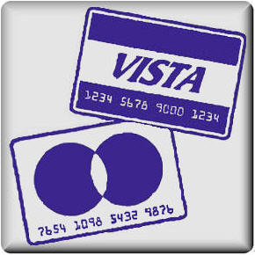 | Credit cards accepted |  | Beauty salon |  | Near an airport |  | Air-conditioning
 | Wheelchair access |  | Coffee Shop |  | Near a bus station |  | Satellite TV
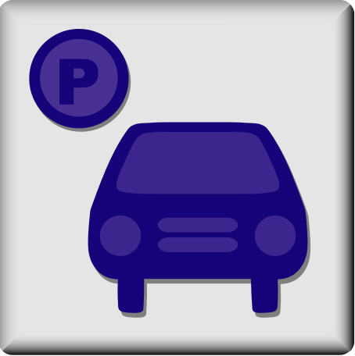 | Parking lot |  | Bar |  | Near a subway or train station |  | Free movies
 | Currency Exchange |  | Gift shop | 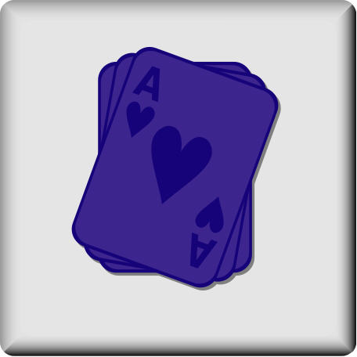 | Near a casino |  | Iron in room
 | Room service |  | Health club |  | Near a beach |  | Hair Dryer in room
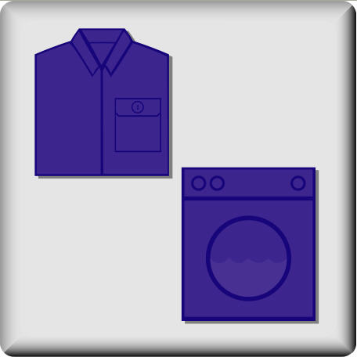 | Laundry service |  | Swimming pool |  | Near a golf course | 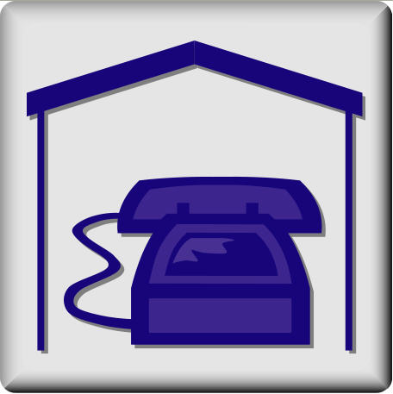 | Phone in room
 | Internet connection |  | Tennis court |  | Near a ski slope | 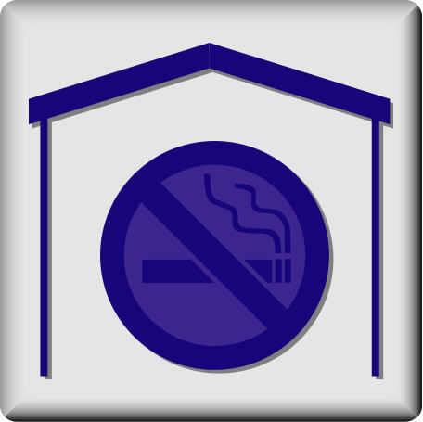 | No smoking
 | Restaurant |  | Airport shuttle |  |  |  | No pets

Appendix B
Symbol Cards

Appendix C
Hotel Sheet A

The Old Western—Las Vegas, Nevada, US

Our 3-night honeymoon package is only \200,000!

You can play in the casinos all day and all night. Or relax and enjoy our swimming pools, health club, gourmet dining and shopping.
Hotel Du Montage—Paris, France

3-night honeymoon package for only \150,000!

In the heart of Paris, our hotel is a great place to begin your sight seeing tour of the ‘City of Lights.’ Walk to the Eiffel Tour and Notre Dame or take a train out to the countryside and go on a wine-tasting adventure.
Ambassador Hotel—Phuket, Thailand

Discount, 3-night honeymoon packages for \100,000.

Spend your honeymoon at our seaside resort in southern Thailand.
Appendix D
Hotel Sheet B

Black Jacks—Las Vegas, Nevada, USA

Our discount, 3-night honeymoon package is only \100,000.

You can play in the casinos all day and all night. Or relax and enjoy our swimming pool and lounge.
The Jacques—Paris, France

Luxurious 3-night honeymoon package begins at \450,000.

In the suburbs of Paris, our hotel is a great place to relax and enjoy luxurious French provincial living. Our chefs are the best and you will enjoy our outdoor activities such as golf, tennis, and swimming.
The King’s Resort Tahiti

Cheapest 3-night honeymoon package only \80,000!

Enjoy the beaches at our simple and affordable hotel.

Appendix E
Client Profile Sample

Chad and Jenny need your help. They are getting married and want you to plan their honeymoon! They love to go to the beach. They don’t want to spend too much money. The hotel doesn’t need to have a lot of amenities or services, but they need a hotel that accepts credit cards and has an airport shuttle. They like to eat and drink, but it is not a problem if the hotel doesn’t have a bar or restaurant.

